Unit 2 Exercise

1. The <app-root> tag is a selector for default app.component.ts file.
2. You can save and reuse component processes and properties with a component template, and then generate components from them; template-based components inherit the template's properties and process.
3. Interpolation is the act of evaluating a string literal containing one or more placeholders and replacing the placeholders with their corresponding values in computer programming.
4. The below image illustrate one way binding of the property title. 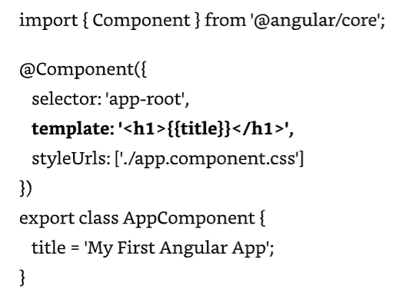
5. Dependence injection is illustrated below where we create the product services and pass it to the constructor. 